**Golden Feather Round Wall Mirror**

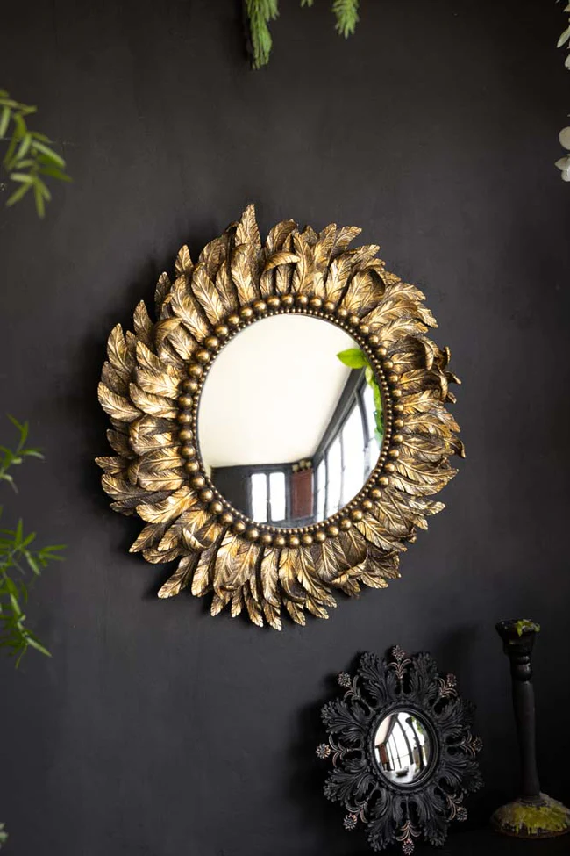The Golden Feather Round Wall Mirror is a stunning blend of elegance and nature-inspired design. With its circular shape and exquisite golden feather accents delicately framing the mirror, it creates a soft, yet luxurious focal point in any room. The golden finish adds a touch of opulence, while the feather details evoke a sense of lightness and grace, making it perfect for both modern and traditional interiors. Its versatile size allows it to complement a variety of spaces, from living rooms and bedrooms to entryways. This mirror not only serves as a functional piece but also as a beautiful work of art that enhances the ambiance of your home.